Fascist’s fantasies: unveiling the truth behind their beliefs

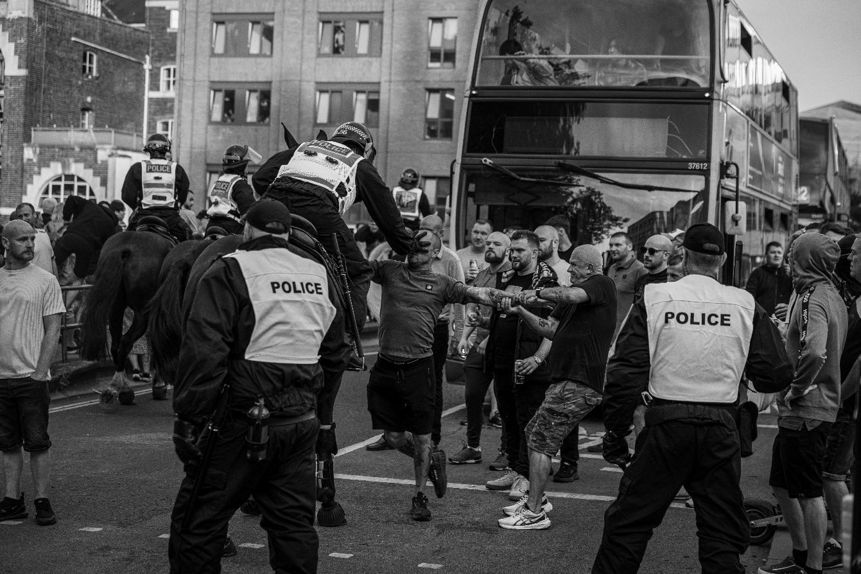As the air echoed with xenophobic chants in Bristol, it became clear despite the EDL’s desire to promote British nationalism, it continues to exert fear and division with their extremist views.

Photo by: L. Ramsey (2024)

The language used by far-right groups, including the English Defence League (EDL), plays a pivotal role in shaping their ideological framework and rallying supporters.

Their discourse revolves around the notion of defending a perceived “national identity” against external threats, claiming multiculturalism and immigration are the two antagonists. Despite this, a radical group is revealed that creates an in-group and out-group dynamic, mustering hatred and violence- [read more here](https://journals.sagepub.com/doi/10.1111/1467-856X.12036).

Amid the Bristol protests, an “us vs them” dichotomy appeared to be entrenched, dividing society into two groups: the “natives” (white, native citizens) and the “threat” (immigrants, Muslims, or ethnic minorities). This strategic tool of division generates fear, attempting to justify exclusion and hostility by echoing the narrative British culture is under threat and needs restoring to protect its purity. A 2015 [PNAS](https://www.pnas.org/doi/10.1073/pnas.1414822112?url_ver=Z39.88-2003&rfr_id=ori%3Arid%3Acrossref.org&rfr_dat=cr_pub++0pubmed) study demonstrates how beliefs are manipulated through propaganda and confirmation bias (Voigtländer and Voth, 2015), both of which are shown by their derogatory chant “Muzzy scum” and slogan “England till I die”. Brindle’s article [here](https://www.tandfonline.com/doi/full/10.1080/17405904.2016.1169196#d1e1432) shares the harrowing truths of the EDL’s manifestos, which can further be displayed in much of their [protest footage](https://www.youtube.com/watch?v=eQhLMSlf_R8) (Crux, 2024). With the tagline "We want our country back” this tool for engagement induces feelings of nostalgia, hurled during protests highlighting the goal of restoring Britain from the supposed detrimental influence of Islam. However, the group’s language is not solely concerned with the protection of identity, but also with their building of an enemy. The possessive adjective “our” and plural pronoun “we” indicate ownership and dominance, used to unite native citizens and build a force fuelled by the desire for division.

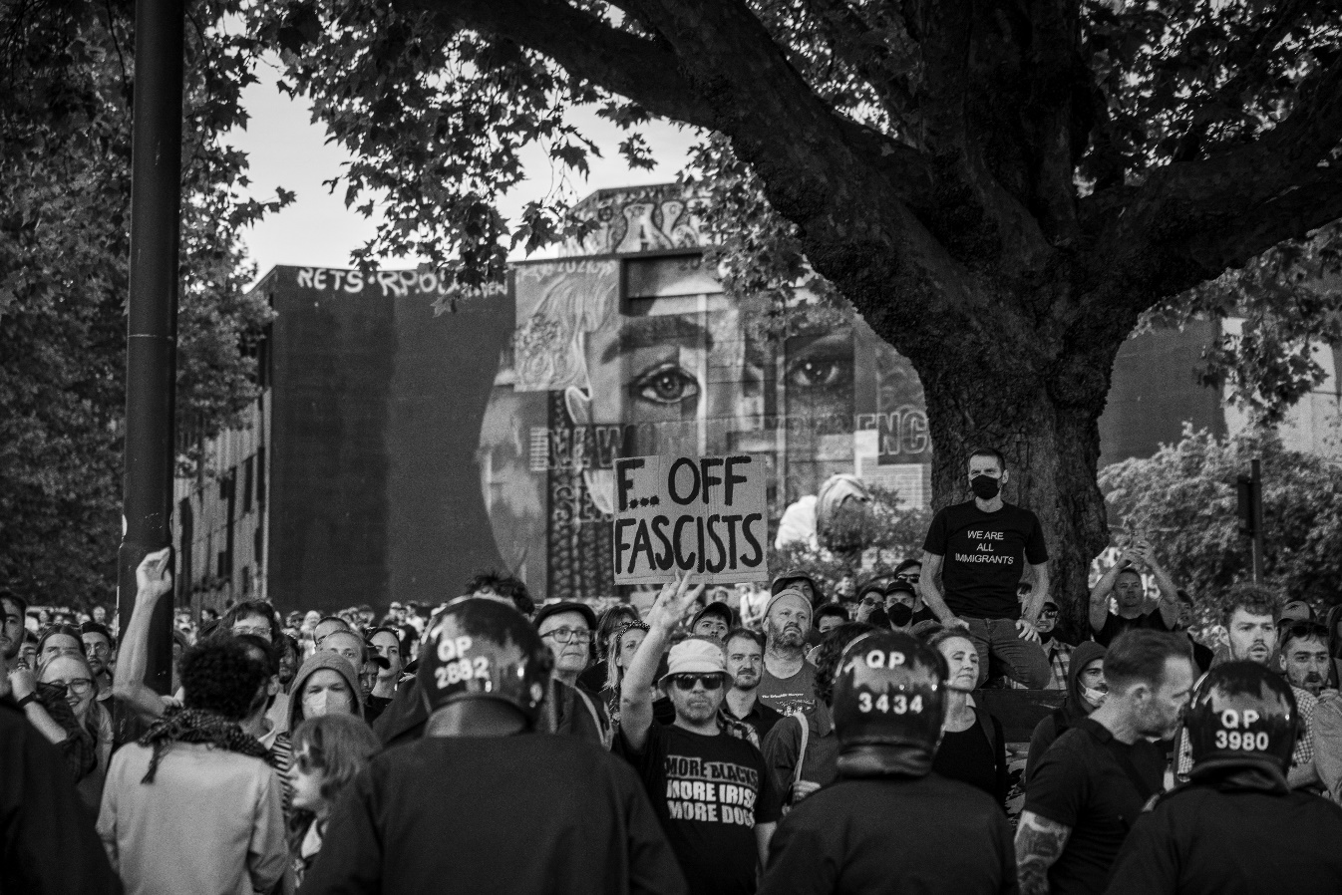

Photo by: L. Ramsey (2024)

Along with this harsh rhetoric came violence, when the radical group embarked on a journey to target hotels housing asylum seekers they claim are “invaders” of the UK. With the mix of derogatory discourse and physical aggression used as tools to overpower and marginalise vulnerable communities, it seeks to advance the EDL’s goal of exclusion.

Pinpointing ways to combat this is difficult, but the number of EDL supporters has decreased since Tommy Robinson’s exit from the group in 2013. A [BBC article](https://www.bbc.co.uk/news/uk-england-bristol-19213204) (BBC News, 2012) reports over 300 members were present at the Bristol protests in 2012, yet in 2024 [roughly 200](https://www.bristolpost.co.uk/news/bristol-news/live-far-right-protest-planned-9457923) were estimated to have attended (Cork et al, 2024). Although this is not a huge difference in Bristol, all links to the EDL on social media platforms have been banished, meaning it’s difficult to sustain a vast extremist faction with the same sense of unity that once held its members together.

But this doesn’t mean the battle against fascists is over; with education and unity, these divisive ideologies can be confronted to help recognize true strength lies in diversity and not division.

References

BBC News (2012) *Policing EDL demo in Bristol cost force £495,000.* Available at: <https://www.bbc.co.uk/news/uk-england-bristol-19213204> (Accessed 13 January).

Brindle, A. (2016) Cancer Has Nothing on Islam: A Study of Discourses by Group Elite and Supporters of the English Defence League. *Critical Discourse Studies* [online]. 13 (4), pp. 444-459. [Accessed 20 November 2024].

Cork, T.,Roig, E.F., Driscoll, A. (2024) *Far-right protest updates as violence breaks out in Bristol city centre.* Available at: <https://www.bristolpost.co.uk/news/bristol-news/live-far-right-protest-planned-9457923> (Accessed 13 January).

Crux (2024). “We Want Our Country Back…” Far-Right Protesters March In Tommy Robinson-Led Rally. *Youtube* [video]. 28 July. Available from: <https://www.youtube.com/watch?v=eQhLMSlf_R8> [Accessed 20 November 2024].

Kassimeris, G., Jackson, L. and , (2014) The Ideology and Discourse of the English Defence League: ‘Not Racist, Not Violent, Just No Longer Silent’. *The British Journal of Politics and International Relations,* [online]. 17 (1), pp. 171-188. [Accessed 04 November 2024].

Ramsey, L (2024) 493A0368 [photograph]. In: Personal Collection [online]. Available from: <https://we.tl/t-G0EF4UEqVU> [Accessed 20 January 2025].

Ramsey, L (2024) 493A0370 [photograph]. In: Personal Collection [online]. Available from: <https://we.tl/t-G0EF4UEqVU> [Accessed 20 January 2025].

Voigtländer, N. and Voth, H.J. (2015) Nazi Indoctrination and Anti-semitic Beliefs in Germany. *Proceedings of the National Academy of Sciences of the United States of America* [online]. 112 (26), p. 7931–7936. [Accessed 05 November 2024]